Wrestling Practice Transportation
Permission Form
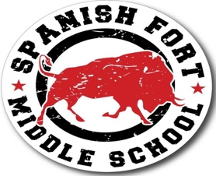

Dear Coach and SFMS Admin:

My child, _______________________________________, has permission to ride the bus to Spanish Fort High School for wresting practice beginning September 4, 2024.

Sincerely,

______________________________________ (Parent or Guardian)

**Please turn into SFMS Upstairs Office. Ms. Sharon Sharp will issue your child the appropriate bus pass.

